**DIGITAL MARKETING ASSIGNMENT**

**QUESTIONS**

1.Create a blog or website using Blogspot and WordPress. Customize the theme design and post new article with 500 words.

SCREENSHOT:

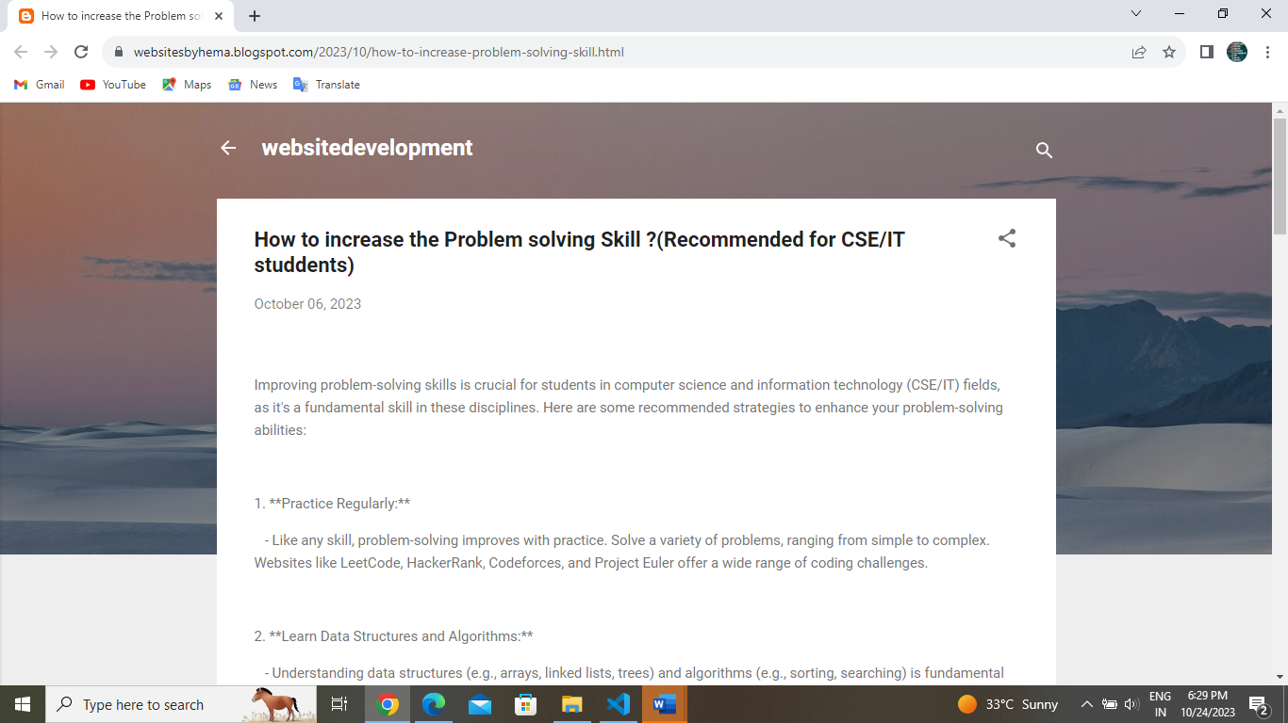

LINK:

<https://websitesbyhema.blogspot.com/2023/10/how-to-increase-problem-solving-skill.html>

2. Create a New Facebook Business Page and post one social media poster for your brand.

SCREENSHOT:

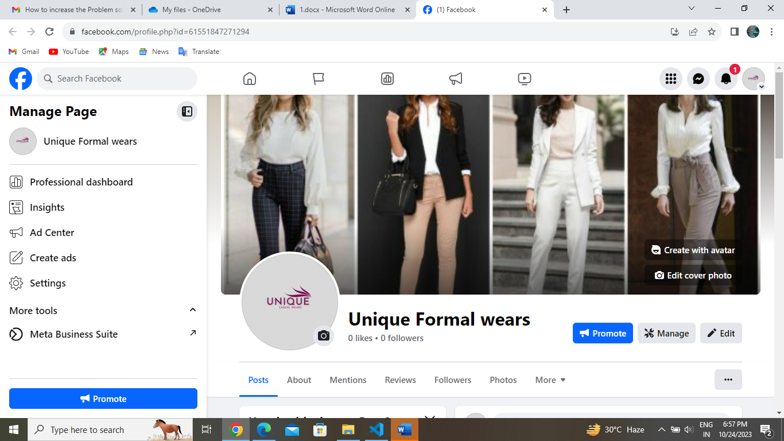

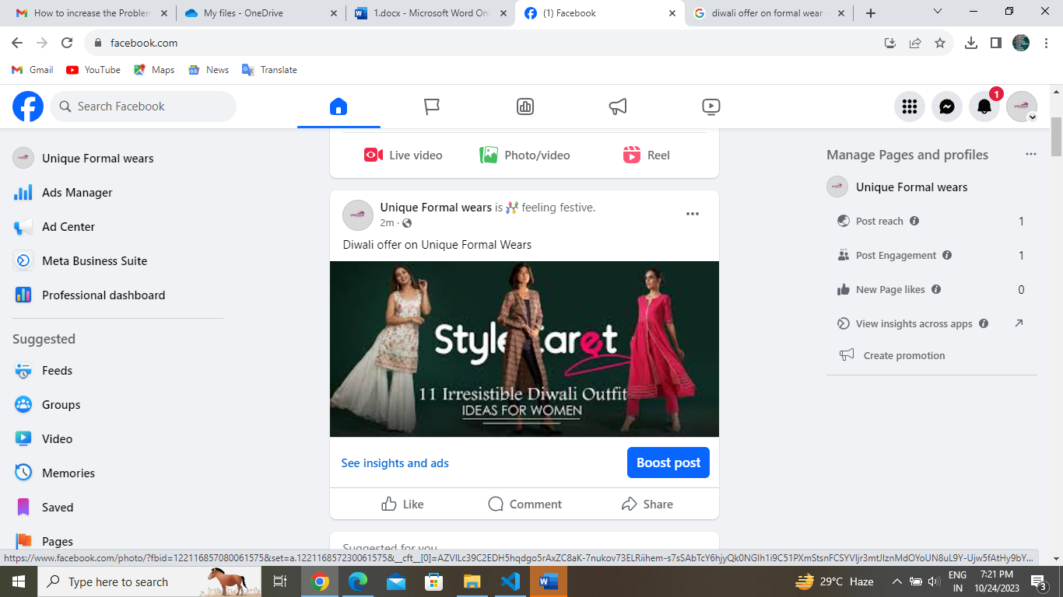

PROFILE LINK:

<https://www.facebook.com/profile.php?id=61551847271294&mibextid=ZbWKwL>

POSTER LINK:

<https://m.facebook.com/story.php?story_fbid=pfbid023akUrQkexJmt2fwRFKwBwzMMnMLcsjnp9FnQBTXWFDS3tsPxTcy3jhJgdrWXWtHel&id=61551847271294&mibextid=Nif5oz>

3. Create and design a social media advertisement poster using canva.

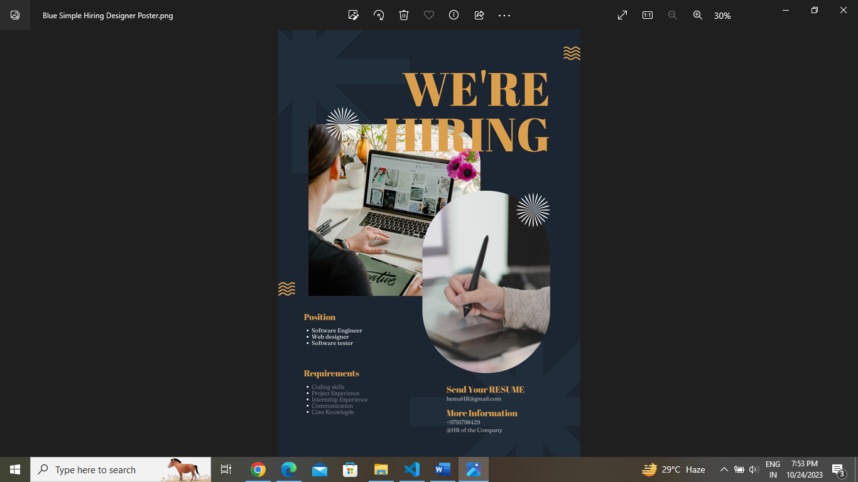

LINK: <https://www.canva.com/design/DAFv6uhbcKI/pFJUSLF4R5sH6NJ34QRPKw/edit?utm_content=DAFv6uhbcKI&utm_campaign=designshare&utm_medium=link2&utm_source=sharebutton>

4. Create email newsletter design using MailChimp or canva tool.

SCREENSHOT:

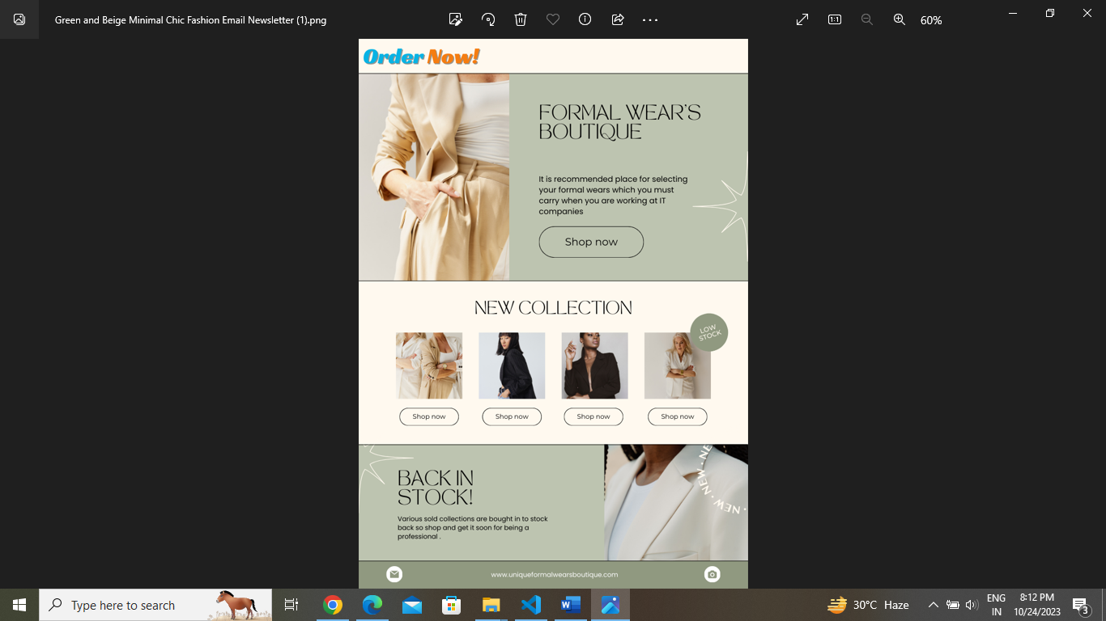

LINK: <https://www.canva.com/design/DAFwjpy4jnc/AYwn_12Sy8IsT30tD6J5bA/edit?utm_content=DAFwjpy4jnc&utm_campaign=designshare&utm_medium=link2&utm_source=sharebutton>